25 Cycles of Solar Magnetic Dipole Moments

Leif Svalgaard, HEPL, Stanford University, Stanford, CA 94305

The idea, based on the Babcock model of the cycle, that the solar polar fields near minimum can be used as predictor of the size of the following sunspot cycle [1] has proven useful and successful the last four cycles, especially for the critical ‘lowest in a 100 years’ Cycle 24 [2]. The ‘Dipole Moment’ (DM), i.e. the difference between the polar fields (using the Wilcox Solar Observatory, WSO, convention that ‘polar fields’ be the average line-of-sight flux density [called the ‘field strength’] above latitudes 55°) in the North and in the South, was taken as a convenient parameter for the purpose of prediction. It was found that the value of DM over the three years preceding the minimum is relatively constant with only a slight decrease over time (due to pole-ward migration of emerging new-cycle flux) was sufficiently stable that its average single value was a good precursor at least for the last four sunspot cycles.

If we can forecast the sunspot number (SN) and the group number (GN) using DM as predictor, then we should be able to hindcast the dipole moment from the SN and/or the GN. This nugget does just that for all cycles since number 1 as well as making a guess of solar activity for Cycle 25. As many cycles [even if smoothed] have two or more ‘peaks’ we use the average SN or GN for the two most active [unsmoothed] yearly values as a measure of the cycle activity following the minima. We have four measurements of [the three-year] DM at minima at WSO since the middle of 1976. The first measurements during 1976-1977 were diminished [~18%] due to excessive scattered light [3] and suffered from being at or after the end of the three-year pre-minimum interval [~12% decrease], so I have increased the 1976-minimum DM value by 30%. Table 1 gives the resulting GN, SN, and DM. Figure 2 shows the correlations between DM and the SN and GN (taken as the independent variables). The relationships, which we assume are physical rather than spurious, are described by the power laws shown, at least within the domains of observed values, plausibly extended slightly at both ends.
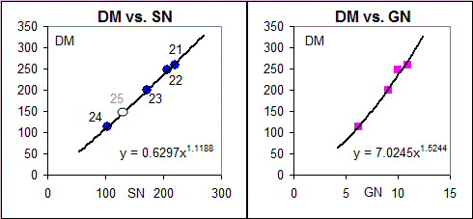

Figure 1: (Left) Correlation of DM vs. the Sunspot Number, SN, for Cycles 21 through 24. The estimated data point for Cycle 25 is shown with an open oval. (Right) Correlation of DM vs. the Group Number, GN. The sunspot data is from SILSO (http://www.sidc.be/silso/datafiles).

Table 1 also shows for Cycles 1 to 24 their DM at minima reconstructed from GN and SN for the following solar maxima, as well as the average of the two reconstructions. Figure 2 graphs the reconstructions and shows DM for each cycle as marked.

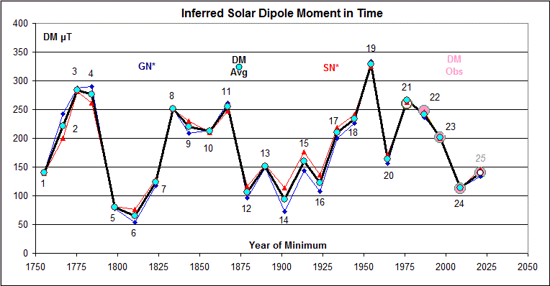

Figure 2: The solar Dipole Moment DM inferred from the sunspot number, SN (red symbols), and from the group number, GN (blue symbols) for the cycles following the minima for which the DM is determined using the regression equations from Figure 1. The average DM for each cycle is shown with a heavy black line with light-blue circles. The observed DM values since Cycle 21 are shown with large circles. An educated guess for Cycle 25 (size between Cycles 20 and 24, based on extrapolated DM from WSO) completes the inferences.

Cycle | Year | Month | Time min | GN max | SN max | WSO DM | DM GN | DM SN | DM avg | B min
1 | 1755 | 5 | 1755.375 | 7.17 | 124 |  | 142 | 138 | 140
2 | 1766 | 8 | 1766.625 | 10.22 | 172 |  | 243 | 200 | 221
3 | 1775 | 6 | 1775.458 | 11.41 | 234 |  | 287 | 281 | 284
4 | 1784 | 5 | 1784.375 | 11.50 | 219 |  | 291 | 262 | 276
5 | 1798 | 6 | 1798.458 | 4.85 | 77 |  | 78 | 81 | 80
6 | 1810 | 7 | 1810.542 | 3.78 | 72 |  | 53 | 76 | 65
7 | 1823 | 4 | 1823.292 | 6.37 | 116 |  | 118 | 129 | 123
8 | 1833 | 8 | 1833.625 | 10.47 | 210 |  | 252 | 250 | 251
9 | 1843 | 7 | 1843.542 | 9.25 | 195 |  | 209 | 230 | 219 | 5.00
10 | 1856 | 1 | 1856.042 | 9.41 | 180 |  | 214 | 210 | 212 | 5.05
11 | 1867 | 4 | 1867.292 | 10.74 | 209 |  | 262 | 248 | 255 | 5.83
12 | 1878 | 12 | 1878.958 | 5.58 | 106 |  | 96 | 116 | 106 | 4.71
13 | 1890 | 2 | 1890.125 | 7.42 | 136 |  | 149 | 154 | 151 | 5.04
14 | 1901 | 9 | 1901.708 | 4.62 | 104 |  | 72 | 114 | 93 | 4.30
15 | 1913 | 6 | 1913.458 | 7.23 | 154 |  | 143 | 177 | 160 | 4.32
16 | 1923 | 4 | 1923.292 | 6.00 | 122 |  | 108 | 136 | 122 | 4.94
17 | 1933 | 9 | 1933.708 | 9.01 | 187 |  | 200 | 219 | 210 | 5.09
18 | 1944 | 4 | 1944.292 | 9.74 | 204 |  | 226 | 241 | 234 | 5.76
19 | 1954 | 4 | 1954.292 | 12.59 | 266 |  | 334 | 324 | 329 | 5.38
20 | 1964 | 8 | 1964.625 | 7.66 | 150 |  | 156 | 171 | 164 | 5.21
21 | 1976 | 3 | 1976.208 | 10.93 | 220 | 260 | 269 | 262 | 266 | 5.78
22 | 1986 | 9 | 1986.708 | 10.02 | 207 | 247 | 236 | 246 | 241 | 5.67
23 | 1996 | 5 | 1996.375 | 9.08 | 172 | 201 | 203 | 200 | 201 | 5.01
24 | 2008 | 12 | 2008.958 | 6.21 | 104 | 113 | 114 | 113 | 113 | 4.22
25 | 2021 | 1 | 2021.042 | 6.90 | 130 | 140 | 133 | 146 | 140 | 4.75

Table 1: Time of minimum for the numbered solar cycles. Average Group Numbers GN and Sunspot Numbers SN for the two highest yearly values for each cycle. DM (μT) observed at WSO for the three years prior to minimum, and the DM inferred from GN and SN, and their average, and finally the inferred HMF strength B (nT) at each minimum. Estimated values are in italics.

The inferred DM values can be used as basis for speculations about the long-term evolution of solar and heliospheric (HMF) activity. An example is the long-term variation of the HMF strength (at Earth), B, which has been derived from geomagnetic data back to the 1840s [4]. It is often believed that the polar fields control the HMF when the low-latitude magnetic fields from active regions have died (or migrated) away at solar minimum. We can test this assertion by plotting B at minimum against DM, Figure 3.

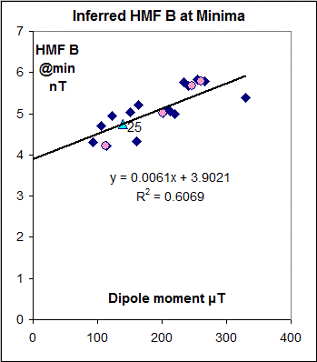

Figure 3: The Heliospheric Magnetic Field strength (at Earth) inferred from geomagnetic data [4] at sunspot minima vs. the solar Dipole Moment DM for the minima form SN and GN (blue diamonds). B(DM) observed at minima before Cycles 21-24 are shown as pink circles and for Cycle 25 as a green triangle.

The excess of B above a ‘floor’ of 3.9 nT does seem to be proportional to DM, raising the question where the floor comes from [5].

References

[1] Schatten, K.H., Scherrer, P.H., Svalgaard, L., Wilcox, J.M., GRL, 5, 411, 1978, at
http://www.leif.org/research/Using%20Dynamo%20Theory%20to%20Predict%20Solar%20Cycle%2021.pdf
[2] Svalgaard, L., Cliver, E.W., Kamide, Y., GRL, 32, L01104, 2005, at
http://www.leif.org/research/Cycle%2024%20Smallest%20100%20years.pdf
[3] Svalgaard, L., Schatten, K.H., AGU Fall Meeting, Abstract SH51A, 2008, at
http://www.leif.org/research/AGU%20Fall%202008%20SH51A-1593.pdf
[4] Svalgaard, L., Ann. Geophys., 32, 633, 2014, at
http://www.leif.org/research/Error-Scale-Values-HLS.pdf
Svalgaard, L., Cliver, E.W., JGR , 115, A09111, 2010, at
http://www.leif.org/research/2009JA015069.pdf
[5] Svalgaard, L., Cliver, E.W., ApJL, 661, L203, 2007

