F10.7 Microwave Flux Matches the Total Disk Averaged Unsigned Magnetic Flux from MDI and HMI

Leif Svalgaard, Xudong Sun (HEPL Stanford University); leif@leif.org

Solar ‘activity’ is usually defined by proxies constructed to somehow measure that component of the output of our variable Sun that is important for Geospace and conditions in the Heliosphere. The longest-running direct proxies are, of course, the venerable Sunspot Number and the Number of Groups (active regions) going back more than 400 years, and recently undergone a facelift, correcting inconsistencies and errors (Clette et al., 2014). Indirect proxies, going back more than 10,000 years, can be constructed from depositions of radionuclides such as 10Be (in ice cores) and 14C (in tree rings).

In 1947 the Canadian Covington discovered (using army surplus materiel) microwave emission from the Sun at 2800 Mhz or 10.7 cm wavelength (e.g. Tapping & Charrois, 1994). The emission can be measured every day regardless of weather and the F10.7 record of the flux [actually the flux density] extends unbroken [except on Sundays in the early years] from 1947 to the present. Observations in Japan agree closely with the Canadian values (Svalgaard & Hudson, 2010) and it is generally accepted that the microwave flux is an excellent [and objective] measure of solar activity.

As we believe that solar activity has its origin in the Sun’s magnetic field, it is of interest to see how observations of the magnetic field agree with the [suitably scaled] F10.7 flux. This actually works both ways as the magnetic field is difficult to measure and the observing instruments are difficult to calibrate. Several series of magnetic data exist from different observatories and they do not agree very well (Riley et al. 2014), as observers at times make [perceived] ‘improvements’ of the magnetometers and also because the measured ‘flux’ or [worse] ‘field’ seems to depend on the spatial resolution of the instrument and on dubious ‘saturation’ effects and zero-level issues.

The two space borne magnetometers, MDI on SOHO at L1 at more than 1 million km distance, and HMI on SDO in geosynchronous orbit much nearer the Earth (Liu et al., 2014) measure the magnetic flux using the [anomalous] Zeeman effect in the spectral lines FeI 617.3 nm and NiI 675.8 nm, respectively. We use the latest versions of magnetic measurements from the two instruments (Xudong: available where and how?) to form a composite data set from 1996 to the present. The analysis proceeds as follows:

Step 1: Compute daily values of the unsigned magnetic flux from the 5-minute MDI Line-of-Sight (LOS) data averaged over the solar disk out to 0.99 of the radius and compute similar daily values from the 720-second HMI LOS data. The data values are expressed in units of 10²² Mx. If a pseudo field strength in Gauss is wanted, divide by the applicable area of the solar disk, 1.5×10²² cm².

Step 2: Compute monthly averages from the daily values. If there [rarely] are less than 10 days with data in any month, the monthly value is interpolated and filled in from neighboring months.

Step 3: The MDI and HMI data overlap during 2010, May through 2011, April and we scale MDI to HMI (MDI* scaled = 0.7429 MDI – 2.847) and form a composite data set as the average of HMI and the scaled MDI. The HMI and scaled MDI values are shown as the upper curves in Figure 1.

Step 4: Get monthly averages of the F10.7 flux (at http://www.spaceweather.gc.ca/) reduced to 1 A.U. and [as is customary] without the URSI correction factor.

Step 5: There is a good, almost linear relationship between the monthly values of F10.7 and of our composite magnetic flux, M. For comparison purposes, remove the slight non-linearity by fitting the relationship to a 4th degree polynomial, calculating the F10.7 flux: F10.7* = 0.0071136 M ⁴ – 0.488305 M ³ + 12.315337 M ² – 125.4736 M + 510.854 sfu (R² = 0.97) corresponding to a given magnetic flux and plot (Figure 1) the computed F10.7* flux derived for the magnetic flux and the observed F10.7 flux.

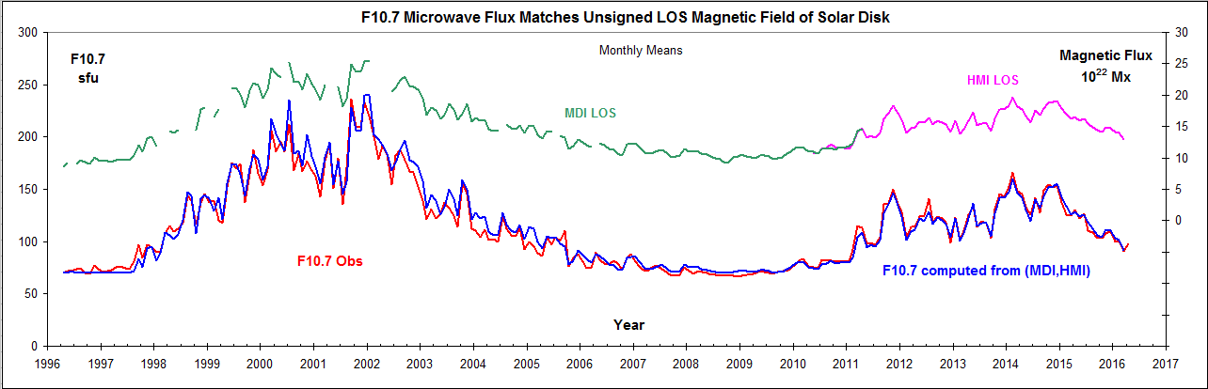
Figure 1: Upper green curve: MDI* LOS flux scaled to match the HMI LOS flux based on their overlap. Upper pink curve: HMI. Lower red curve: observed F10.7 flux reduced to 1 A.U. Blue curve: F10.7* computed from the magnetic flux of the composite record. All curves have 1-month resolution.
There is a remarkable agreement between the observed and calculated microwave fluxes, lending credence to the accuracy and physical significance of both. Repeating the analysis using the radial magnetic flux yields the same amazing agreement; in fact, even slightly better. Using the magnetic data from Wilcox Solar Observatory (WSO) yields a similar result, attesting to the stability of the measurements at Stanford. We have also used the result to detect [and correct] changes in the calibration of the SOLIS series. We suggest that the F10.7 record can serve as an [almost] absolute reference scale for the solar magnetic field.

References:

Clette, F.; Svalgaard, L.; Vaquero, J.M.; Cliver, E.W.: (2014) Space Sci Rev 186, 35
Liu, Y.; Hoeksema, J. T.; Scherrer, P. H.; Schou, J.; Couvidat, S.; Bush, R. I.; Duvall, T. L.; Hayashi, K.; Sun, X.; Zhao, X.: (2014) Solar Physics 279, 295
Riley, P.; Ben-Nun, M.; Linker, J. A.; Mikic, Z.; Svalgaard, L.; Harvey, J.; Bertello, L.; Hoeksema, T.; Liu, Y.; Ulrich, R.: (2014) Solar Physics 289, 769
Svalgaard, L.; Hudson, H.S.: (2010) SOHO-23, ASP Conference Series 428, 325
Tapping, K.F.; Charrois, D.P.: (1994) Solar Physics 150, 305

