Comparing Super-Synoptic Maps from MDI and HMI
Leif Svalgaard, Jan. 2018

The Super-Synoptic Map [see: http://hmi.stanford.edu/hminuggets/?p=2146 for definition of a SSM] for the entire SOHO/MDI mission calculated from the radial magnetic fields (assuming the field is radial) look like this [Carrington rotations 1908-2107]:
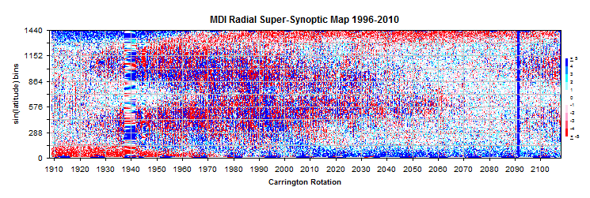
The usual butterfly diagram is evident as well as the reversals of the polar fields. It is also clear that the ‘remapping’ of fields at very high latitudes does not work quite as expected: when a pole is behind the limb [March or the South; September for the North] the remapped data points above ~80° latitude have clearly the wrong sign; see the map within the oval. This happens in both hemispheres, and also for HMI:
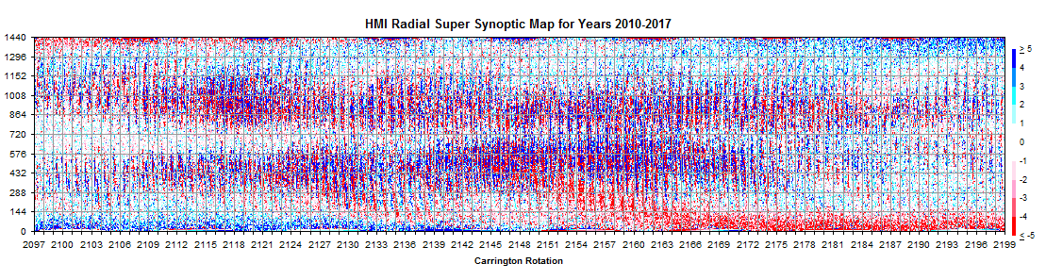
Such an anomaly has implications for the determination of the polar fields. It is of interest to construct a composite SSM for the entire time since 1996 (Cycle 23 and most of 24):
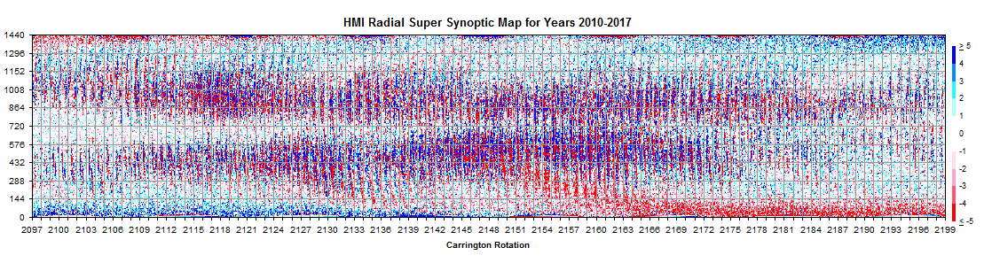
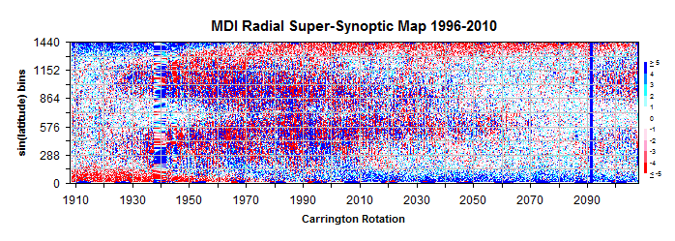
MDI
HMI
But for that we must first put the measurements on the same scale [arbitrarily chosen to be HMI’s]. An issue here is if the scale is the same, independent of position [latitude]?
To investigate that, we regress the field strength [flux density] for ‘pixels’ on HMI synoptic maps against simultaneous values on MDI synoptic maps for 10 latitude bands on the rotations 2097-2107 where the data overlap. We find that in each band there is a simple proportional relationship between the two instruments [with negligible offset]. For

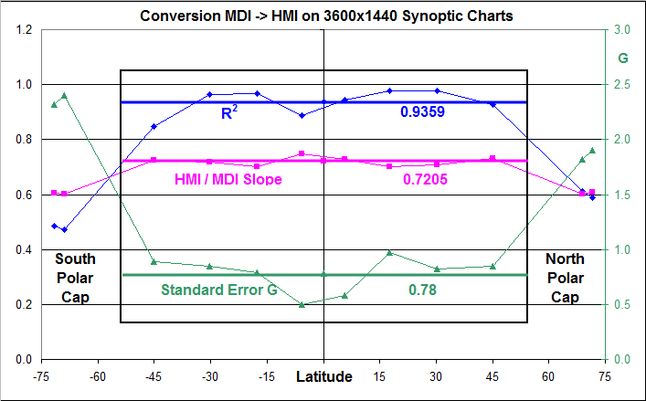

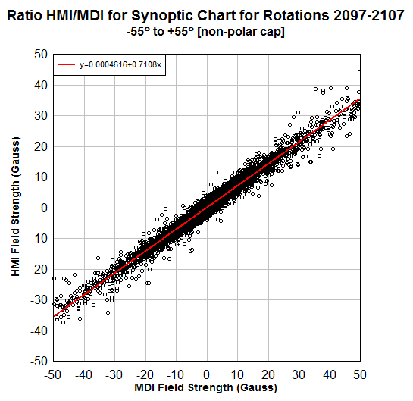
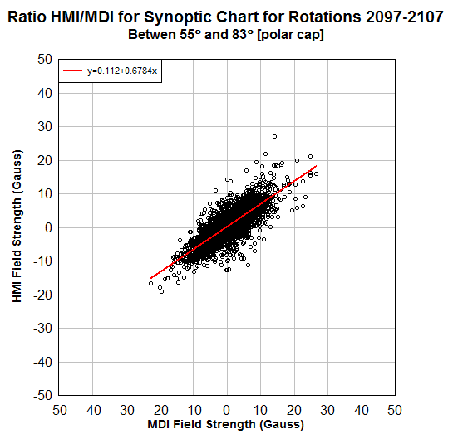

the polar band the conversion factor is 0.6, while for the rest of the surface the factor is rather a constant 0.72.

The following Figure shows the SSMs for HMI and MDI to the same scale for their times of overlap; they look very similar.

