Polar Fields and Prediction of Solar Cycle 25

There is growing acceptance of the suggestion by Schatten et al. (Schatten, Scherrer, Svalgaard, Wilcox: GRL 5, 411, 1978) http://www.leif.org/research/Using%20Dynamo%20Theory%20to%20Predict%20Solar%20Cycle%2021.pdf that the Sun’s polar fields during a few years leading up to solar minimum is a ‘seed’ for the next solar cycle, being transported to and amplified in the interior by the solar global dynamo. If so, Predicting the size of the next solar cycle then comes down to predicting [or better: measuring] the polar fields, which traditionally are considered to be the fields pole-wards of 55° latitude. A recent Workshop in Nagoya, Japan addressed that problem with the emphasis of ‘surface flux transport’ models where the observed distribution and magnetic flux on the surface [where we can measure it] is transported by observed [and extrapolated into the future] flows of plasma on the solar surface. My [very long] presentation can be found here http://www.leif.org/research/Observations-polar-magnetic-fields-and-Cycle-25-prediction.pdf. Slides 124-125 show the evolution of the polar fields for the last two cycles.

I have just revisited this issue and present here (Figure 1) an updated graph of the polar fields [up to yesterday]. Wilcox Solar Observatory [WSO] data are shown with bluish colors, while data from the Helioseismic and Magnetic Imager on the SDO spacecraft are shown with reddish colors. There are three sets of curves showing the Northern Polar Fields, the Southern polar fields, and the so-called ‘Dipole Moment’ [the difference between the North and the South]. Due to the 7.16° angle between the Sun’s rotation axis and the orbital plane of the Earth and to a very strong concentration of the magnetic flux at the poles [see Slides 6 & 9-10 of my presentation] the ‘raw’ polar fields observed by WSO exhibit a very strong annual modulation [by a factor of two]. If you filter the WSO data to remove variations with a period of one year this modulation disappears. The ‘poor man’s filter’ is just to take the difference between the North and the South pole data as what is lost by one pole [by going behind the solar limb] is gained by the other pole, so that the difference is less affected by the apparent tipping back and forth of the axis. This assumes that the polar fields are equally well formed and stable. For 2016 this was not the case as the South polar fields were stable [and showed the annual modulation], but the North polar fields were not. This anomalous behavior [which also happened in 2003, so not that unusual] is marked by the yellow rectangle on Figure 1. A problem with the WSO data [dirty lens in first half of 2017] was resolved and the data have been [preliminarily] corrected [ http://www.leif.org/research/AGU-2017-Fall-SH51C-2497.pdf ]. As the spatial resolution of HMI is of the order of 1” [i.e. some 30,000 times better than WSO] we can avoid most of the annual modulation by observing what is actually above 55° rather than what is above 49° or 62° which is the varying lower latitude of the pole-most WSO pixel. So, HMI does not show any appreciable annual modulation.

The scales of the two observatories are different [we don’t quite know why, although it has to do with the different spatial resolution], but we can overcome that problem by scaling the data the match each other. The Dipole Moment [DM] is what we use as predictor. It has now reached a value numerically slightly larger than at the previous minimum 2006-2008 and may be still growing. The observations in the coming year 2018 are crucial to assessing the final value of DM, but based on what we have now, one would predict Solar Cycle 25 to be slightly larger than Cycle 24.

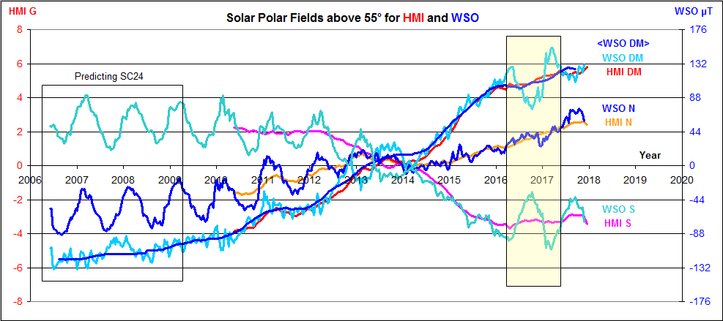

Figure 1: the evolution of the Solar Polar Fields as measured by WSO and HMI magnetographs.

If the polar fields can forecast the solar cycle maximum for the next cycle, the cycle size should be usable to hindcast the polar fields for earlier cycles where no direct observations of the magnetic field of the Sun are available. Figure 2 is one attempt of doing this [ http://hmi.stanford.edu/hminuggets/?p=2084 ]:

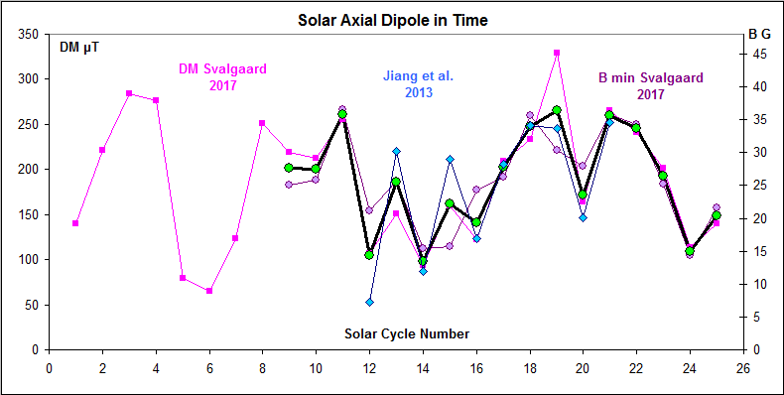

Figure 2: The solar Dipole Moment DM inferred from the sunspot number, SN (pink symbols), and from the group number, GN (blue symbols) for the cycles following the minima for which the DM is determined using the regression equations. The average DM for each cycle is shown with a heavy black line with light-blue circles. The observed DM values since Cycle 21 are shown with large circles. An educated guess for Cycle 25 (size between Cycles 20 and 24, based on extrapolated DM from WSO) completes the inferences.

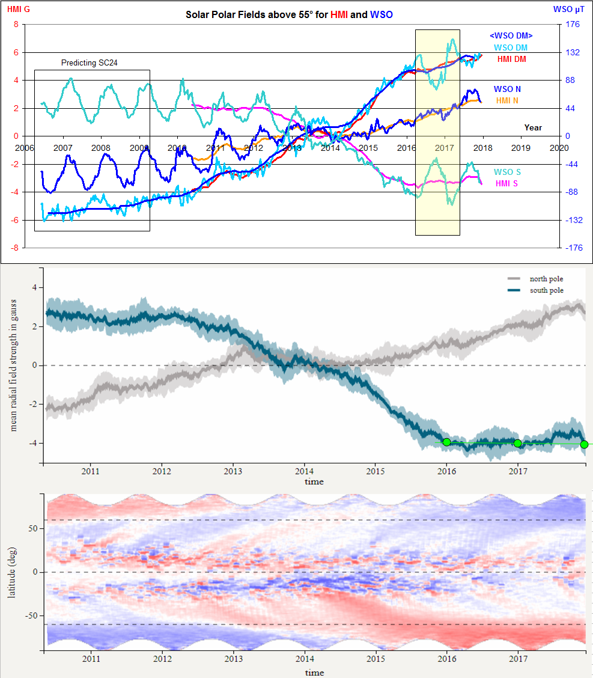

Figure 3: The latest…

